Electron Configuration
There are 4 types of orbital:
- S :
  - Spherical shape
  - Higher energy means higher radius
  - Every shell has only 1 S orbital
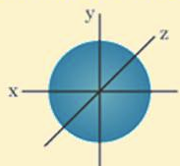
- P:
  - Dumb-bell shape
  - 3 orbital types, referred to as P_{x}, P_{y}, P_{z}. Because of the axis they are on (x,y,z)
  - These orbitals are at right angles to each other
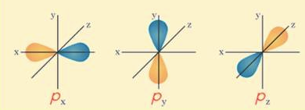
- D/F:
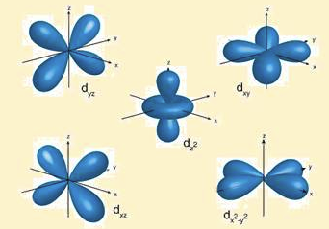
  - Shells 3-5 have 5 d orbitals.
  - Shells 4-7 have 7 f orbitals
  - Varying Shapes

